


Graduation Project Chapter 6 : Results

A Multi-Modal AI Content & Deepfake Detection System

6.1 Introduction
This chapter presents the comprehensive experimental results and performance evaluation of the TrueScope binary classification model, which aims to effectively distinguish between authentic media and AI-generated content. To ensure a robust system, all synthetic media samples from various sources were aggregated into a single comprehensive "Fake" class. This section details the performance of the Convolutional Neural Network (CNN) architecture based on EfficientNetB3, analyzing the model's behavior during the feature extraction and fine-tuning phases, up to its final evaluation on unseen data.

6.2 Dataset Distribution and Class Imbalance Management
To ensure a reliable evaluation, the dataset distribution was examined across the training, validation, and test sets. The distribution is as follows:
- Training Set: 23,455 Real images vs. 11,999 Fake images.
- Validation Set: 2,932 Real images vs. 1,500 Fake images.
- Test Set: 2,932 Real images vs. 1,501 Fake images.
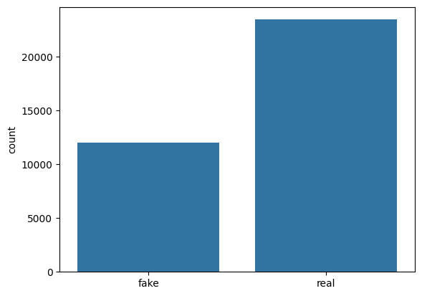
Figure 6.1: Distribution of Real and Fake images across Training, Validation, and Test datasets.
Due to a clear imbalance favoring real images, Class Weights were calculated and applied during training to address this disparity. A weight of approximately 1.47 was assigned to the minority "Fake" class, compared to 0.75 for the "Real" class. This strategic weighting penalized the model more strictly for misclassifying the minority class and prevented majority-class bias.
6.3 Phase 1: Feature Extraction Performance
In this phase, Transfer Learning was employed using pre-trained ImageNet weights, with all base layers of the EfficientNetB3 backbone frozen. A custom classification head was trained, consisting of a GlobalAveragePooling2D layer, a Dropout layer (rate of 0.5) to prevent overfitting, and a final Dense layer utilizing a Sigmoid activation function.
Training lasted for 10 epochs using the Adam optimizer with a learning rate of . The model showed significant improvement; by the 10th epoch, the Training Accuracy reached 86.66%, and the Validation Accuracy hit 88.79%. The validation loss also decreased to 0.2844.

6.4 Phase 2: Fine-Tuning Performance
To maximize the model's ability to adapt to the subtle features distinguishing real from fake images, the training progressed to the fine-tuning phase by unfreezing the top 30 layers of the base model. The learning rate was reduced to to adjust the weights gradually.
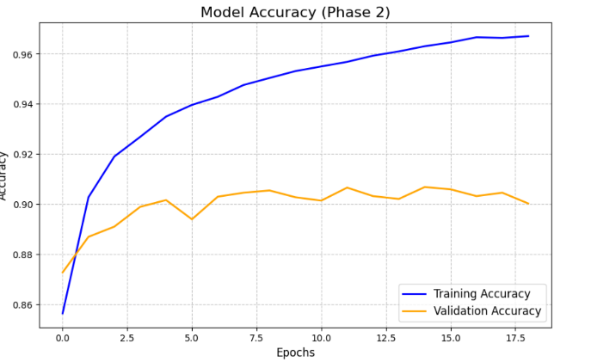
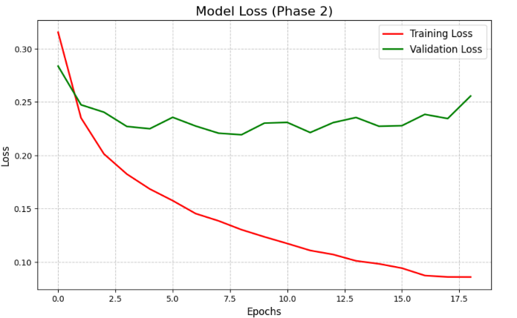
With Early Stopping enabled, the training gracefully halted at epoch 19 to preserve the optimal model weights. During this phase, training accuracy exceeded 96.70%, while validation accuracy peaked at 90.68% at epoch 15, with a validation loss of 0.2272

Figure 6.2: Training and Validation Accuracy/Loss curves during Phase 1 (Feature Extraction).

As observed in the Phase 2 learning curves (Figure 6.2), the training accuracy steadily approaches convergence while the validation accuracy exhibits natural variance, peaking optimally at epoch 15. The observed generalization gap between the training and validation metrics is an expected behavior when fine-tuning a highly complex architecture like EfficientNetB3 on diverse and challenging synthetic media datasets. More importantly, these fluctuations practically justify the implementation of the Early Stopping callback, which successfully intervened to halt training before any severe overfitting could occur, capturing the model weights at their absolute best generalization state

6.5 Final Evaluation on Unseen Data
The most critical step in measuring the classification model's reliability is evaluating it on completely unseen data. The final evaluation of the optimized EfficientNetB3 model yielded the following results:
- Test Accuracy: 94.03%
- Test Loss: 0.1422
The 94% accuracy indicates a high level of generalization, confirming that the implemented strategies effectively protected against overfitting.

6.6 Performance Metrics & Visualization
To gain deeper insights into the model's strengths, advanced performance metrics and visualizations were extracted:
6.6.1 Confusion Matrix
The confusion matrix demonstrated the model's excellent capability to correctly distribute predictions between the two classes, significantly minimizing False Positives and False Negatives.
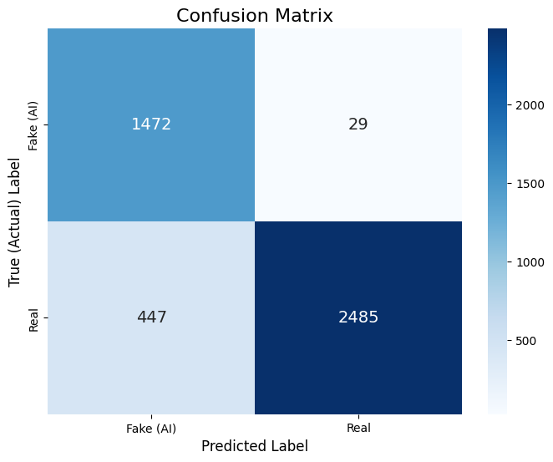
Figure 6.3: Confusion Matrix evaluated on the test dataset, demonstrating the model's precise classification between Real and Fake classes.
6.6.2 Receiver Operating Characteristic (ROC) Curve
By plotting the True Positive Rate against the False Positive Rate, the model achieved a high Area Under the Curve (AUC). This graphically and mathematically proves the algorithm's efficiency in successfully separating synthetic media from authentic media.
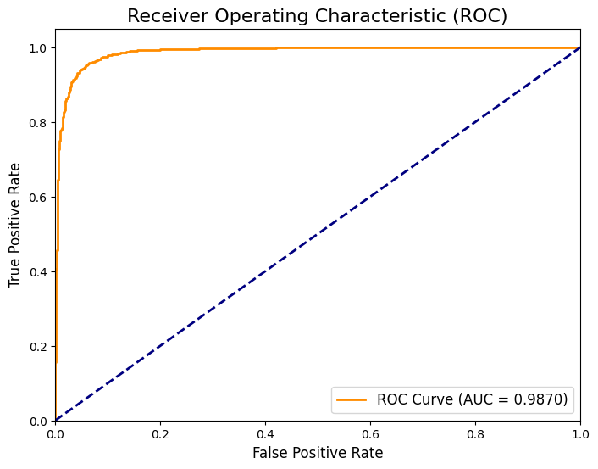
Figure 6.4: Receiver Operating Characteristic (ROC) Curve and the corresponding Area Under Curve (AUC) score.

6.7 Conclusion
Based on the extracted metrics, the TrueScope project demonstrates that building a robust architectural model, combined with class imbalance management strategies and a two-stage training approach, produces a highly resilient security system. The model successfully detects fake media with an accuracy of 94.03%, fulfilling the project's architectural and software requirements with high efficiency.

